**Form Master – Form Barang (frmBarang)**

1. Buat file form baru pada project penjualan.
2. Desain form barang tersebut seperti berikut:

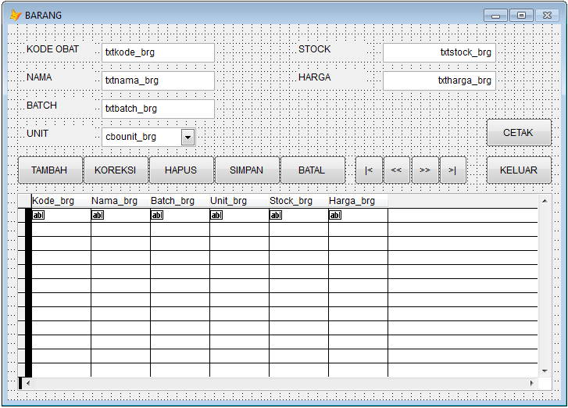

|  |  |  |
| --- | --- | --- |
| **Object** | **Nama** | **Tipe Isian** |
| Form Barang | frmBarang | Character |
| Textbox Kode obat | Txtkode_brg | Character |
| Textbox Nama | Txtnama_brg | Character |
| Textbox Batch | Txtbatch_brg | Character |
| Combobox Unit | Cbounit_brg | - |
| Textbox Stock | Txtharga_brg | Numeric |
| Textbox Harga | Txtharga_brg | Numeric |
| Tombol Tambah | cmdTambah |  |
| Tombol Koreksi | cmdKoreksi |  |
| Tombol Hapus | cmdHapus |  |
| Tombol Simpan | cmdSimpan |  |
| Tombol Batal | cmdBatal |  |
| Tombol |< | cmdTop |  |
| Tombol << | cmdPrev |  |
| Tombol >> | cmdNext |  |
| Tombol >| | cmdEnd |  |
| Tombol Keluar | cmdKeluar |  |
| Tombol Cetak | cmdCetak |  |
| Grid | Grid1 |  |

1. Atur **“Tab Order Object”** dengan cara **klik icon Set Tab Order**

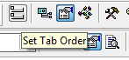

Dengan urutan berikut:

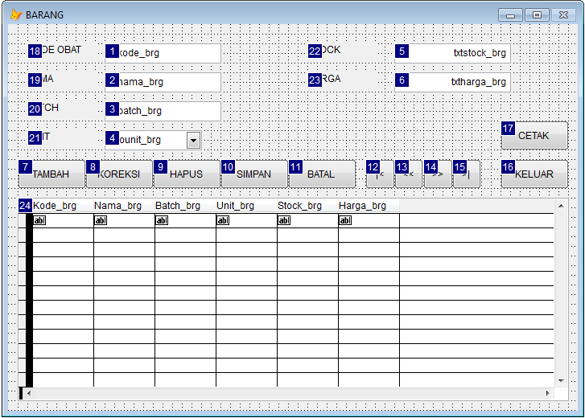

1. Tambah **“data environment”** pada form dengan tabel tbl_barang dengan cara, klik kanan pada Form 🡪 Pilih Data Environment 🡪 Pilih tbl_barang 🡪 klik tombol Add. Kemudian tutup Window Data Environment.

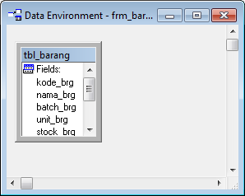

1. Buat method baru pada form dengan cara, klik menu **Form 🡪Edit Property/Method**. Tambahkan method dengan cara, klik tombol **“New Method”** berikut ini:

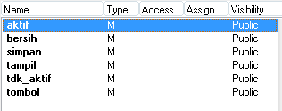

1. Tulis kode program pada masing-masing method seperti dibawah ini:

|  |  |  |  |
| --- | --- | --- | --- |
| **Object:** | frmBarang | **Procedure:** | Aktif |

thisform.SetAll("enabled",.T.,"TextBox")

thisform.SetAll("enabled",.T.,"ComboBox")

|  |  |  |  |
| --- | --- | --- | --- |
| **Object:** | frmBarang | **Procedure:** | Tdk_aktif |

thisform.SetAll("enabled",.F.,"TextBox")

thisform.SetAll("enabled",.F.,"ComboBox")

|  |  |  |  |
| --- | --- | --- | --- |
| **Object:** | frmBarang | **Procedure:** | Tombol |

PARAMETER T1,T2,T3,T4,T5,T6,T7,T8,T9,T10

THISFORM.CmdTambah.ENABLED=T1

THISFORM.CmdKoreksi.ENABLED=T2

THISFORM.Cmdhapus.ENABLED=T3

THISFORM.Cmdsimpan.ENABLED=T4

THISFORM.Cmdbatal.ENABLED=T5

THISFORM.Cmdtop.ENABLED=T6

THISFORM.Cmdprev.ENABLED=T7

THISFORM.Cmdnext.ENABLED=T8

THISFORM.Cmdend.ENABLED=T9

THISFORM.Cmdkeluar.ENABLED=T10

|  |  |  |  |
| --- | --- | --- | --- |
| **Object:** | frmBarang | **Procedure:** | Bersih |

THISFORM.txtkode_brg.VALUE=" "

THISFORM.txtnama_brg.VALUE=" "

THISFORM.Txtbatch_brg.VALUE=" "

THISFORM.cbounit_brg.VALUE=" "

THISFORM.txtstock_brg.VALUE=0

THISFORM.txtharga_brg.VALUE=0

|  |  |  |  |
| --- | --- | --- | --- |
| **Object:** | frmBarang | **Procedure:** | Simpan |

IF CMD=1

APPEND BLANK

ENDIF

REPL KODE_BRG WITH THISFORM.txtkode_brg.VALUE

REPL NAMA_BRG WITH THISFORM.txtnama_brg.VALUE

REPL BATCH_BRG WITH THISFORM.txtbatch_brg.VALUE

REPL UNIT_BRG WITH THISFORM.Cbounit_brg.VALUE

REPL STOCK_BRG WITH THISFORM.txtstock_brg.VALUE

REPL HARGA_BRG WITH THISFORM.TXTharga_brg.Value

|  |  |  |  |
| --- | --- | --- | --- |
| **Object:** | frmBarang | **Procedure:** | Tampil |

THISFORM.Txtkode_brg.VALUE=KODE_BRG

THISFORM.Txtnama_brg.VALUE=NAMA_BRG

THISFORM.Txtbatch_brg.VALUE=BATCH_BRG

THISFORM.Cbounit_brg.VALUE=UNIT_BRG

THISFORM.txtstock_brg.VALUE=STOCK_BRG

THISFORM.txtharga_brg.VALUE=HARGA_BRG

1. Tuliskan kode berikut pada procedure **Activate** form Barang

|  |  |  |  |
| --- | --- | --- | --- |
| **Object:** | frmBarang | **Procedure:** | Activate |

PUBLIC CMD,PESAN

thisform.tombol(.T.,.T.,.T.,.F.,.F.,.T.,.T.,.T.,.T.,.T.)

thisform.tdk_aktif()

GO TOP

THISFORM.TAMPIL()

1. Tuliskan kode berikut pada procedure **Load** form Barang

|  |  |  |  |
| --- | --- | --- | --- |
| **Object:** | frmBarang | **Procedure:** | Load |

CLOSE INDEX

CLOSE ALL DATABASE

SET DELE ON

SET DEFA TO D:/PENJUALAN/

USE

USE TBL_BARANG

SET ORDER TO TAG idx_kdbrg

1. Tuliskan kode berikut pada procedure **Click** Tombol Tambah

|  |  |  |  |
| --- | --- | --- | --- |
| **Object:** | cmdTambah | **Procedure:** | Click |

CMD=1

thisform.tombol(.F.,.F.,.F.,.T.,.T.,.F.,.F.,.F.,.F.,.F.)

thisform.aktif()

THISFORM.BERSIH()

THISFORM.txtkode_brg.SETFOCUS()

1. Tuliskan kode berikut pada procedure **Click** Tombol Koreksi

|  |  |  |  |
| --- | --- | --- | --- |
| **Object:** | cmdKoreksi | **Procedure:** | Click |

CMD=2

thisform.tombol(.F.,.F.,.F.,.T.,.T.,.F.,.F.,.F.,.F.,.F.)

thisform.aktif()

THISFORM.txtnama_brg.SETFOCUS()

1. Tuliskan kode berikut pada procedure **Click** Tombol Hapus

|  |  |  |  |
| --- | --- | --- | --- |
| **Object:** | cmdHapus | **Procedure:** | Click |

PESAN=MESSAGEBOX("DATANYA AKAN DIHAPUS",32+4,"HAPUS")

IF PESAN=6

DELE

ENDIF

GO TOP

THISFORM.TAMPIL()

THISFORM.REFRESH()

THISFORM.GRID1.REFRESH()

1. Tuliskan kode berikut pada procedure **Click** Tombol Simpan

|  |  |  |  |
| --- | --- | --- | --- |
| **Object:** | cmdSimpan | **Procedure:** | Click |

IF THISFORM.txtkode_brg.VALUE=" "

MESSAGEBOX("KODE BARANG KOSONG",48,"KONFIRMASI")

THISFORM.txtkode_brg.VALUE=" "

THISFORM.txtkode_brg.SETFOCUS()

ELSE

thisform.tombol(.T.,.T.,.T.,.F.,.F.,.T.,.T.,.T.,.T.,.T.)

thisform.tdk_aktif()

THISFORM.SIMPAN()

ENDIF

THISFORM.REFRESH()

THISFORM.GRID1.REFRESH()

1. Tuliskan kode berikut pada procedure **Click** Tombol Batal

|  |  |  |  |
| --- | --- | --- | --- |
| **Object:** | cmdBatal | **Procedure:** | Click |

thisform.tombol(.T.,.T.,.T.,.F.,.F.,.T.,.T.,.T.,.T.,.T.)

thisform.tdk_aktif()

1. Tuliskan kode berikut pada procedure **Click** Tombol Keluar

|  |  |  |  |
| --- | --- | --- | --- |
| **Object:** | cmdKeluar | **Procedure:** | Click |

thisform.Release()

1. Tuliskan kode berikut pada procedure **Click** Tombol |<

|  |  |  |  |
| --- | --- | --- | --- |
| **Object:** | cmdTop | **Procedure:** | Click |

GO TOP

THISFORM.TAMPIL()

1. Tuliskan kode berikut pada procedure **Click** Tombol <<

|  |  |  |  |
| --- | --- | --- | --- |
| **Object:** | cmdPrev | **Procedure:** | Click |

IF BOF()

GO TOP

ELSE

SKIP -1

IF BOF()

GO TOP

ENDIF

ENDIF

THISFORM.TAMPIL()

1. Tuliskan kode berikut pada procedure **Click** Tombol >>

|  |  |  |  |
| --- | --- | --- | --- |
| **Object:** | cmdNext | **Procedure:** | Click |

IF EOF()

GO BOTTOM

ELSE

SKIP 1

IF EOF()

GO BOTTOM

ENDIF

ENDIF

THISFORM.TAMPIL()

1. Tuliskan kode berikut pada procedure **Click** Tombol >|

|  |  |  |  |
| --- | --- | --- | --- |
| **Object:** | cmdEnd | **Procedure:** | Click |

GO BOTTOM

THISFORM.TAMPIL()

1. Buat daftar unit barang obat pada Combobox **cbounit_brg**, dengan cara: **klik kanan cbounit_brg** 🡪 **Pilih Builder** 🡪**Fill the list with: Data entered by hand**, tambahkan daftar berikut:

* BOX
* CUP
* FLS
* STR
* TUBE
* VIAL

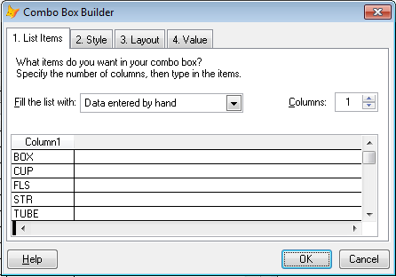

1. Atur sumber data pada grid1 dengan cara: **klik kanan Grid1 🡪 Pilih Builder 🡪 Pilih database and Table 🡪 Pilih field yang akan ditampilkan pada grid.**

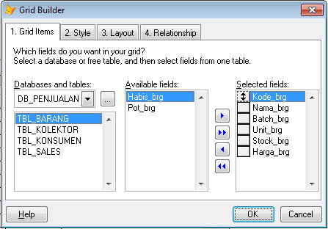

1. Simpan form dan jalankan!.